**IDEATION PHASE**

**DEFINE THE PROBLEM STATEMENTS**

|  |  |
| --- | --- |
| **Date** | 6 October 2022 |
| **Team ID** | PNT2022TMID47589 |
| **Project Name** | Personal Assistance for Seniors who are Self-Reliant |
| **Maximum Marks** | 2 Marks |

**CUSTOMER PROBLEM STATEMENT :**

Senior citizen or Elders may often fail to consume their medication whether it was from forgetting to take the medicine, from taking medicine at the wrong time or even from taking too much medicine. Therefore, the family members or caretaker has to remind them to take the pills on time. So, we have focus on those elders who having difficulty to take medication on time independently. You may also keep track them.

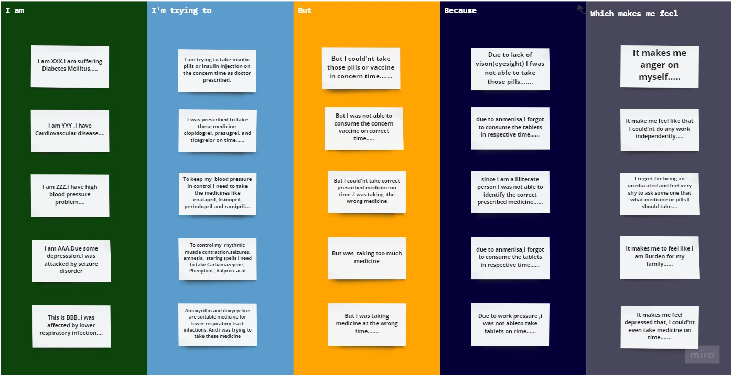

**Reference link :**

https://miro.com/welcomeonboard/emtudEkxRGZhZzl4anRWNFp4OGpIRVFPN0xlTDFOMW82ZnVQa1lGMW51NUhtSEZGSklRTnJmMGVUbTlGc3A5TnwzNDU4NzY0NTM1MTc1MTE5MjU3fDI=?share_link_id=271231241427

|  |  |  |  |  |  |
| --- | --- | --- | --- | --- | --- |
| **Problem Statement**  **(PS)** | **I am** | **I’m Trying To** | **But** | **Because** | **Which makes me feel** |
| **PS-1** | **I am XXX.I am suffering Diabetes Mellitus.** | **I am trying to take insulin pills or insulin injection on the concern time as doctor prescribed.** | **But I could'nt take those pills or vaccine in concern time.** | **Due to lack of vison(eyesight) I fwas not able to take those pills.** | It makes me anger on myself. |
| **PS-2** | **I am YYY .I have Cardiovascular disease.** | **I was prescribed to take these medicine  clopidogrel, prasugrel, and ticagrelor on time.** | **But I was not able to consume the concern vaccine on correct time.** | due to anmenisa, I forgot to consume the tablets in respective time. | It make me feel like that I could'nt do any work independently. |
| **PS-3** | **I am ZZZ.I have high blood pressure problem.** | **To keep my  blood pressure in control I need to take the medicines like enalapril, lisinopril, perindopril and ramipril.** | But I could'nt take correct prescribed medicine on time .I was taking  the wrong medicine | since I am a illiterate person I was not able to identify the correct prescribed medicine. | I regret for being an uneducated and feel very shy to ask some one that what medicine or pills I should take. |
| **PS-4** | **I am AAA.Due some depresssion.I was attacked by seizure disorder** | **To control my  rhythmic muscle contraction,seizures, amnesia,  staring spells i need to take Carbamazepine,  Phenytoin , Valproic acid** | But was  taking too much medicine. | Due to anmenisa, I forgot to consume the tablets in respective time. | It makes me to feel like I am Burden for my family. |
| **PS-5** | **This is BBB..i was affected by lower respiratory infection.** | **Amoxycillin and doxycycline are suitable medicine for lower respiratory tract infections. And i was trying to take these medicine** | But I was taking medicine at the wrong time. | Due to work pressure ,i was not ableto take tablets on rime. | It makes me feel depressed that, I could'nt even take medicine on time. |